TEAM ID: NM2025TMID14955

Team Members

Team Leader: Divakar T

Team Member1: Abinash E

Team Member2: Sanjay E

Team Member3: Sanjay V

Problem Statement:

Employees in the organization need a quick and efficient way to request laptops for work. The current process is manual and prone to delays, with no dynamic form behavior to guide users or ensure accurate data collection. To address this, a Service Catalog item needs to be created, allowing users to easily required a laptop, with dynamic fields, clear instructions, and additional functionality like resetting the form if needed. The solution should also ensure all changes are tracked for governance and deployment.

Objective:

Provide a quick and user-friendly laptop request process. Add dynamic form behavior for accuracy. Include reset option and clear instruments. Automate approvals and fulfillment. Track changes for governance and compliance.

Skills:

UIPath RPA, Tanzu Application Service

TASK INITIATION

Milestone 1: Update Set

Activity 1: Create Local Update Set

1. Open ServiceNow.
2. Click All and type Update Sets.
3. Select Local Update Sets.
4. Create New Update Sets.
5. Fill in Details.
6. Submit and Make Current.
7. Verify Activation.

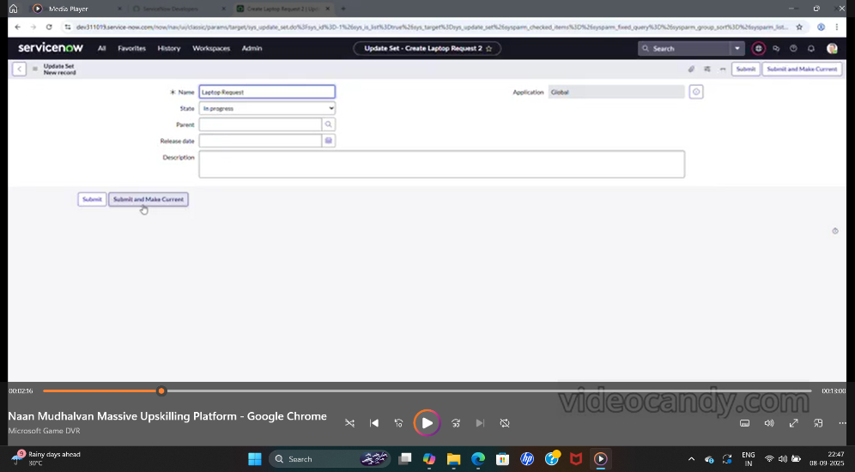

Milestone 2: Service Catalog Item

Activity 1: Create Service Catalog Item

1. Open ServiceNow.
2. Go to Service Catalog.
3. Maintain Items.
4. Create a New Item.
5. Fill Catalog Item Details.

Name: Laptop Request

Catalog: Service Catalog

Category: Hardware

Short Description: Use this item to request a new laptop.

1. Save the Item.
2. Verify Item.

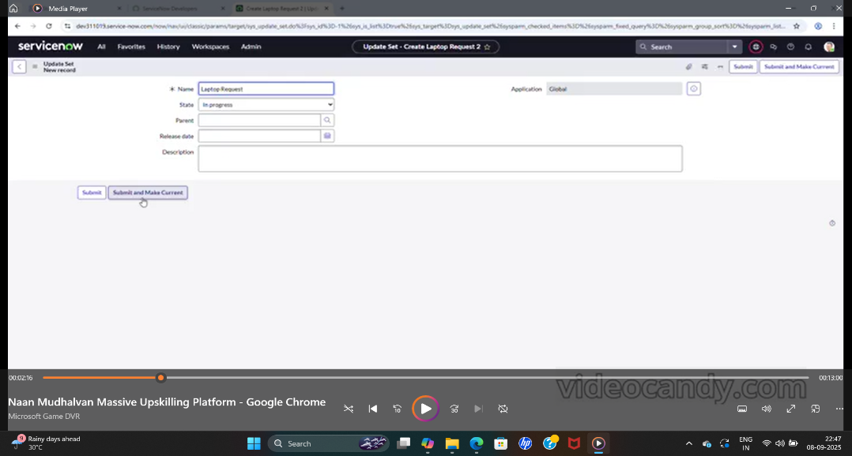

Activity 2: Add Variables

1. Open the Catalog Item.
2. Got to Variables Related List.
3. Create First Variable.

Question: Laptop Model

Type: Single Line Text

Name: laptop_model

Order:100

1. Create Justification Variable.

Question: Justification

Type: Multi Line Text

Name: justification

Order:200

1. Create Additional Accessories Checkbox

Question: Additional Accessories

Type: Checkbox

Name: additional_accessories

Order:300

1. Create Accessories Details Variable.

Question: Accessories Details

Type: Multi Line Text

Order:400

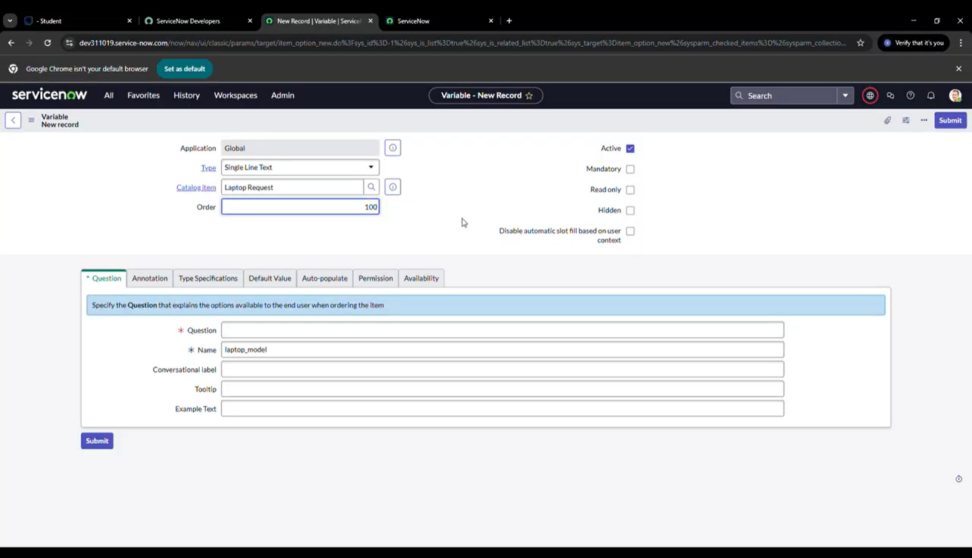

7.Save Catalog Item.

8.Preview.

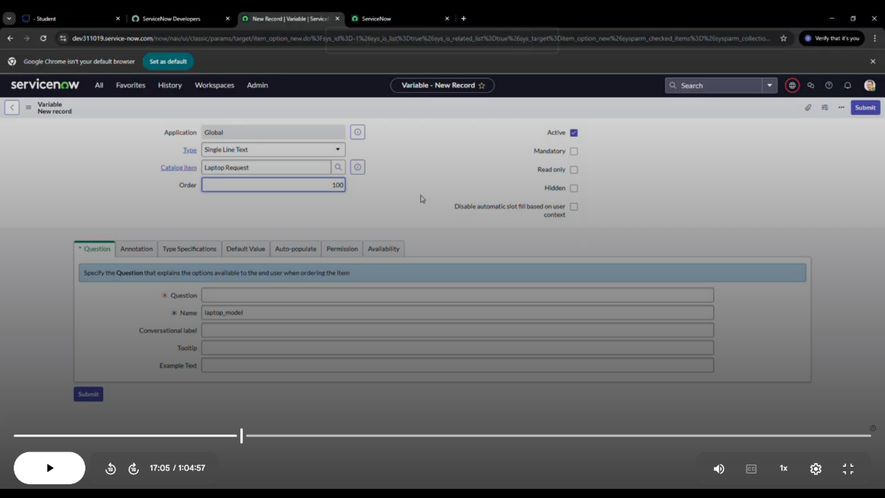

Milestone 3: UI Policy

Activity 1: Create Catalog Ui Policies

1. Open instance.
2. In the Navigator type Service Catalog >> Maintain Items and open Laptop Request.
3. Scroll down to the Related Lists area and click Catalog UI Policies>> New.
4. On the new Catalog UI Policy record

Short description: Show accessories details

Tick Applies on a Catalog Item view

1. In the When to apply/ Condition builder add

Field = additional_accessories, Operator = is, Value= true

1. Save the Catalog UI Policy.
2. In the same Catalog UI Action record, open the Catalog UI Actions rekated list>> New.
3. Create a Catalog UI Action to change the variable behaviour when the condition is met:

Variable name= accessories_details

Order=100

Set Mandatory= True

Set Visible= True

1. Save the Catalog UI Action. Then return to the Catalog UI Policy and click save again.

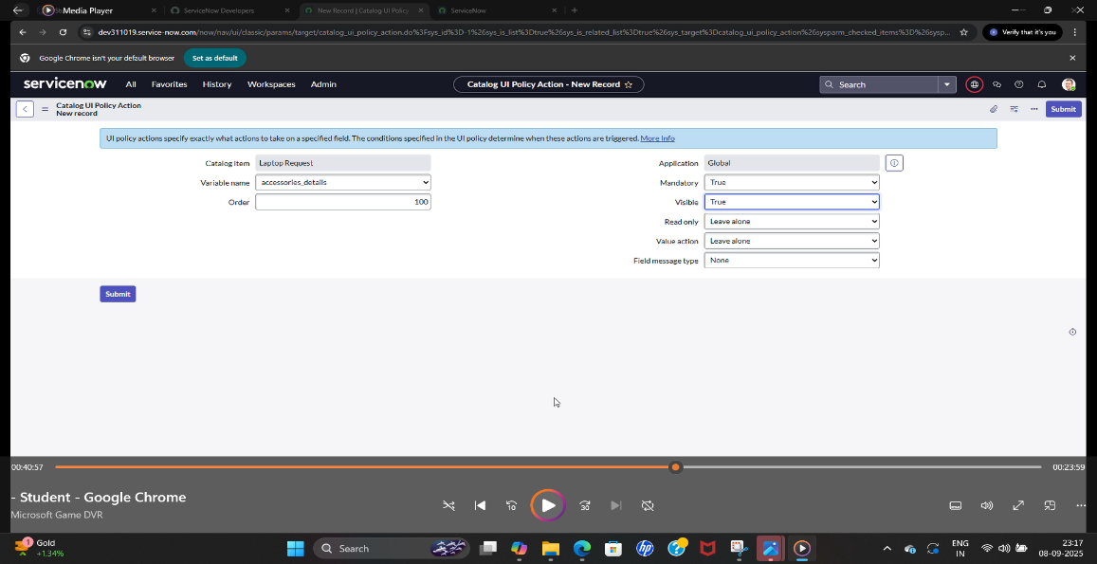

Milestone 4: UI Action

Activity 1: Create Ui Action

* + 1. Open instance.
    2. App Navigator>> System Definition>> UI Actions>> New.
    3. Fill the UI Action form:

Action name: Reset form

Table: shopping cart (sc_cart)

Order: 100

Client: Checked

* + 1. Put the client script

function resetForm() {

g_form.clearForm();

alert(“The form has been reset.”);

}

* + 1. Save the UI Action.

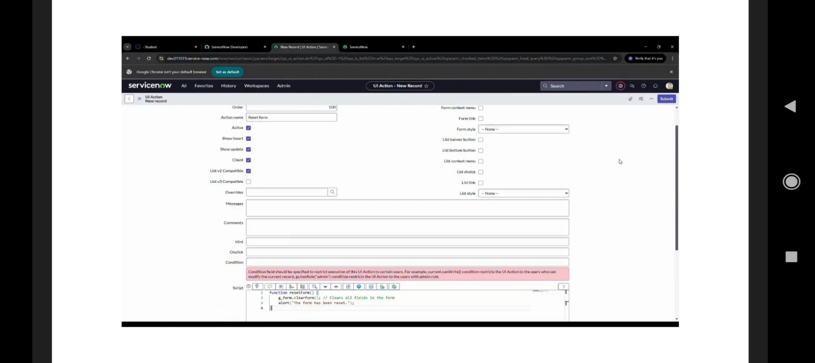

Milestone 5: Export Update Set

Activity 1: Exporting Changes To Another Instances

1. Open instance.
2. Select local update set.
3. App Navigator>> Service Catalog>> Maintain Items. Select Laptop Request.
4. Select the state to ‘Complete’
5. In the related list Update tab, updates are visible which we perform under this update set.
6. Click on export to XML, it download one file.

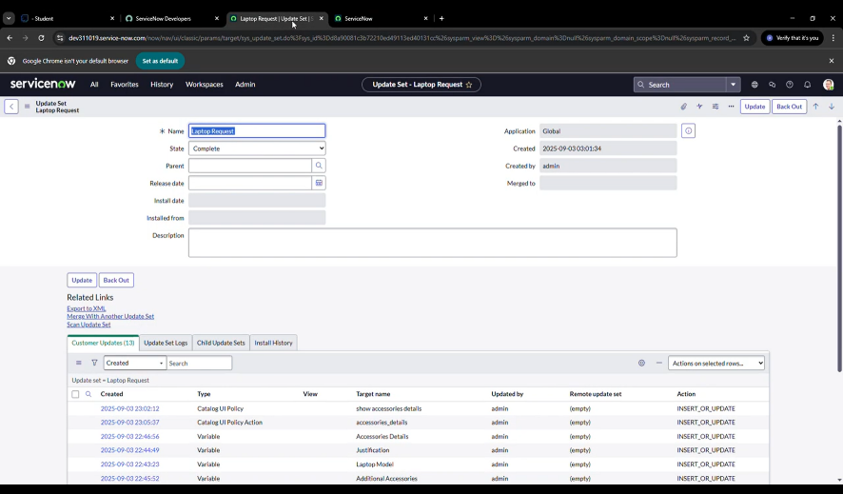

Milestone 6: Login To Another Instance

Activity 1: Retrieving The Update Set

* + 1. Open target instance in new window.
    2. In the Application Navigator search for Retrieved update sets and open System Update Sets>> Retrieved Update Sets.
    3. Click Import Update Set from XML link.
    4. Choose the XML file you exported from your instance and click Upload.

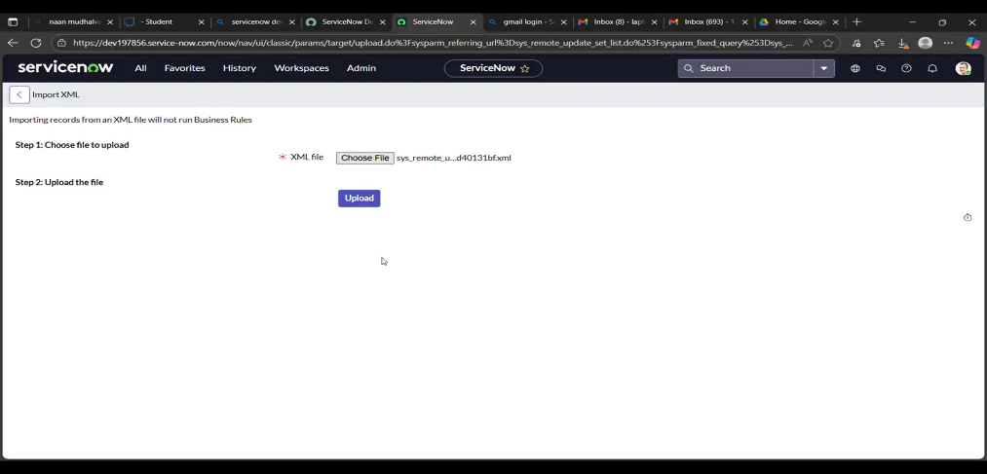

* + 1. After upload the update set will appear in Retrieved Update Sets. Open that retrieved update set record.
    2. Confirm the Update Set.
    3. If no errors, click Commit Update Set.

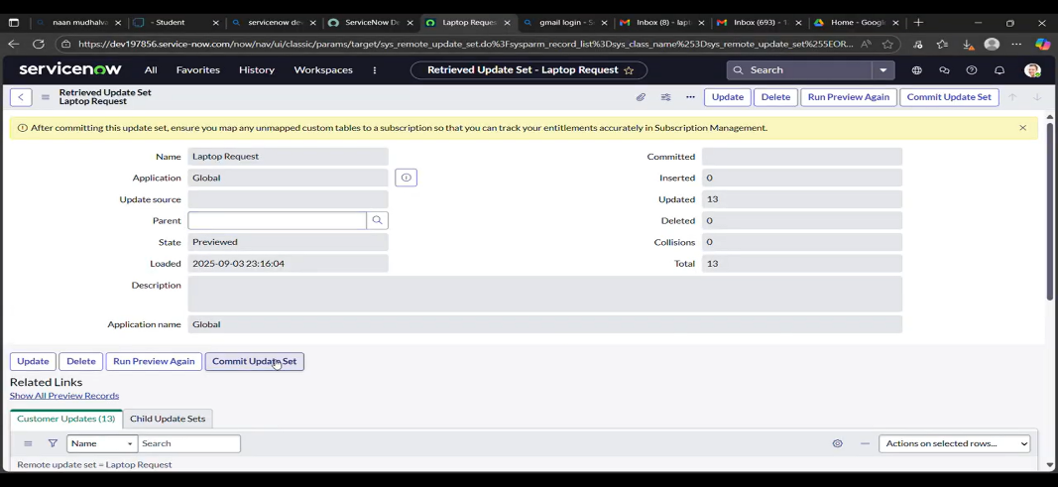

Milestone 7: Testing

Activity 1: Test Catalog Item

1. Open instance.
2. Navigate to Service Catalog>> Catalogs.
3. Open the Hardware Category.
4. Search for Laptop Request.
5. Open and Test the Catalog Item.
6. Verify Variables.
7. Submit a Test Request.

